LC#84 LARGEST RECTANGLE IN HISTOGRAM
Given an array of integers heights representing the histogram's bar height where the width of each bar is 1, return the area of the largest rectangle in the histogram.

Example 1:
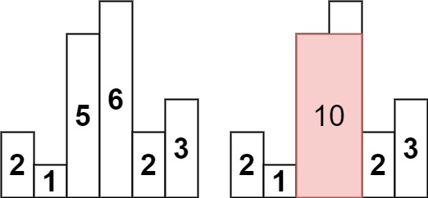
Input: heights = [2,1,5,6,2,3]
Output: 10
Explanation: The above is a histogram where width of each bar is 1.
The largest rectangle is shown in the red area, which has an area = 10 units.

HARD PROBLEM :
APP 1: TC:O(5N) SC: O(4N)
->find pse and nse (indexes) in the array
-> calculate and update the area
->width = r-l-1 , height = curr[i] and then compute the area

CODE:
class Solution {
public int largestRectangleArea(int[] h) {
int[] pse = findPSE(h);
int[] nse = findNSE(h);
int maxArea = 0;
for(int i = 0; i < h.length; i++) {
int width = nse[i] - pse[i] - 1;
int area = h[i] * width;
maxArea = Math.max(maxArea, area);
}
return maxArea;
}

int[] findPSE(int[] h) {
int[] res = new int[h.length];
Stack<Integer> s = new Stack<>();

for(int i = 0; i < h.length; i++) {
while(!s.isEmpty() && h[s.peek()] >= h[i])
s.pop();

res[i] = s.isEmpty() ? -1 : s.peek();
s.push(i);
}

return res;
}
int[] findNSE(int[] h) {
int[] res = new int[h.length];
Stack<Integer> s = new Stack<>();

for(int i = h.length - 1; i >= 0; i--) {
while(!s.isEmpty() && h[s.peek()] >= h[i])
s.pop();

res[i] = s.isEmpty() ? h.length : s.peek();
s.push(i);
}
return res;
}
}

OPTIMAL:
APP:
-> do pse when popping calculate the area
-> if pse doing fails means current element is the nse of the previous element
CODE:
class Solution {
public int largestRectangleArea(int[] h) {
int maxArea = 0;
Stack<Integer> s = new Stack();
for(int i = 0 ; i<=h.length ; i++)
{
int height = 0;
if(i==h.length)
height = 0;
else
height = h[i];

while(!s.isEmpty() && h[s.peek()]>=height)
{
int currheight = h[s.pop()];
int nse = i;
int pse = s.isEmpty()?-1:s.peek();
int width = nse-pse-1;
maxArea = Math.max(maxArea , width*currheight);
}
s.push(i);
}
return maxArea; }}

LC#85 MAXIMAL RECTANGLE:
Given a rows x cols binary matrix filled with 0's and 1's, find the largest rectangle containing only 1's and return its area.

Example 1:
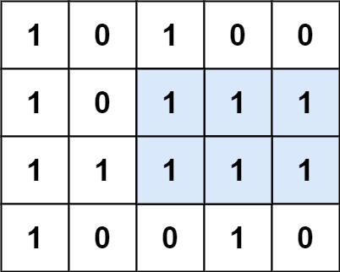
Input: matrix = [["1","0","1","0","0"],["1","0","1","1","1"],["1","1","1","1","1"],["1","0","0","1","0"]]
Output: 6
Explanation: The maximal rectangle is shown in the above picture.
APP:
->same as histogram but compute for every with increasing their count when 1 arrived

CODE:
class Solution {
public int rectHistogram(int[] arr)
{
int maxArea = 0 ;
Stack<Integer> s = new Stack();
int n = arr.length;
for(int i = 0 ; i<=n;i++)
{
int currheight;
if(i==n)
currheight = 0;
else
currheight = arr[i];
while(!s.isEmpty() && arr[s.peek()]>=currheight)
{
int height = arr[s.pop()];
int nse = i;//because if we pop means curr is small
int pse = s.isEmpty()?-1 : s.peek();
int width = nse-pse-1;
maxArea = Math.max(maxArea , width*height);
}
s.push(i);
}
return maxArea;
}

public int maximalRectangle(char[][] m) {
int maxArea = 0;
int arr[] = new int[m[0].length];
for(int i = 0 ; i< m.length ; i++)
{

for(int j = 0;j<m[0].length;j++)
{
if(m[i][j]=='1')
arr[j]+=1;
else
arr[j] = 0;
}
maxArea = Math.max(maxArea , rectHistogram(arr));
}
return maxArea;

}
}

